**Lab 5 Report**

**Name: Alex Ma**

**UT EID: am74874**

**Section:**

**Checklist:**

**Part 1 –**

1. Design file (.v) for the Ripple Carry Adder
2. Test-bench
3. Complete Table 1 from the simulation

|  |  |  |  |  |
| --- | --- | --- | --- | --- |
| A[3:0] | B[3:0] | Cin | Sum[3:0] | Cout |
| 0001 | 0101 | 0 | 0110 | 0 |
| 0111 | 0111 | 0 | 1110 | 0 |
| 1000 | 0111 | 1 | 0000 | 1 |
| 1100 | 0100 | 0 | 0000 | 1 |
| 1000 | 1000 | 1 | 0001 | 1 |
| 1001 | 1010 | 1 | 0100 | 1 |
| 1111 | 1111 | 0 | 1110 | 1 |

**Table 1.** Testcases for Ripple Carry Adder Verification

1. Constraints File (Just the uncommented portion)
2. Simulation waveform for the above test-cases

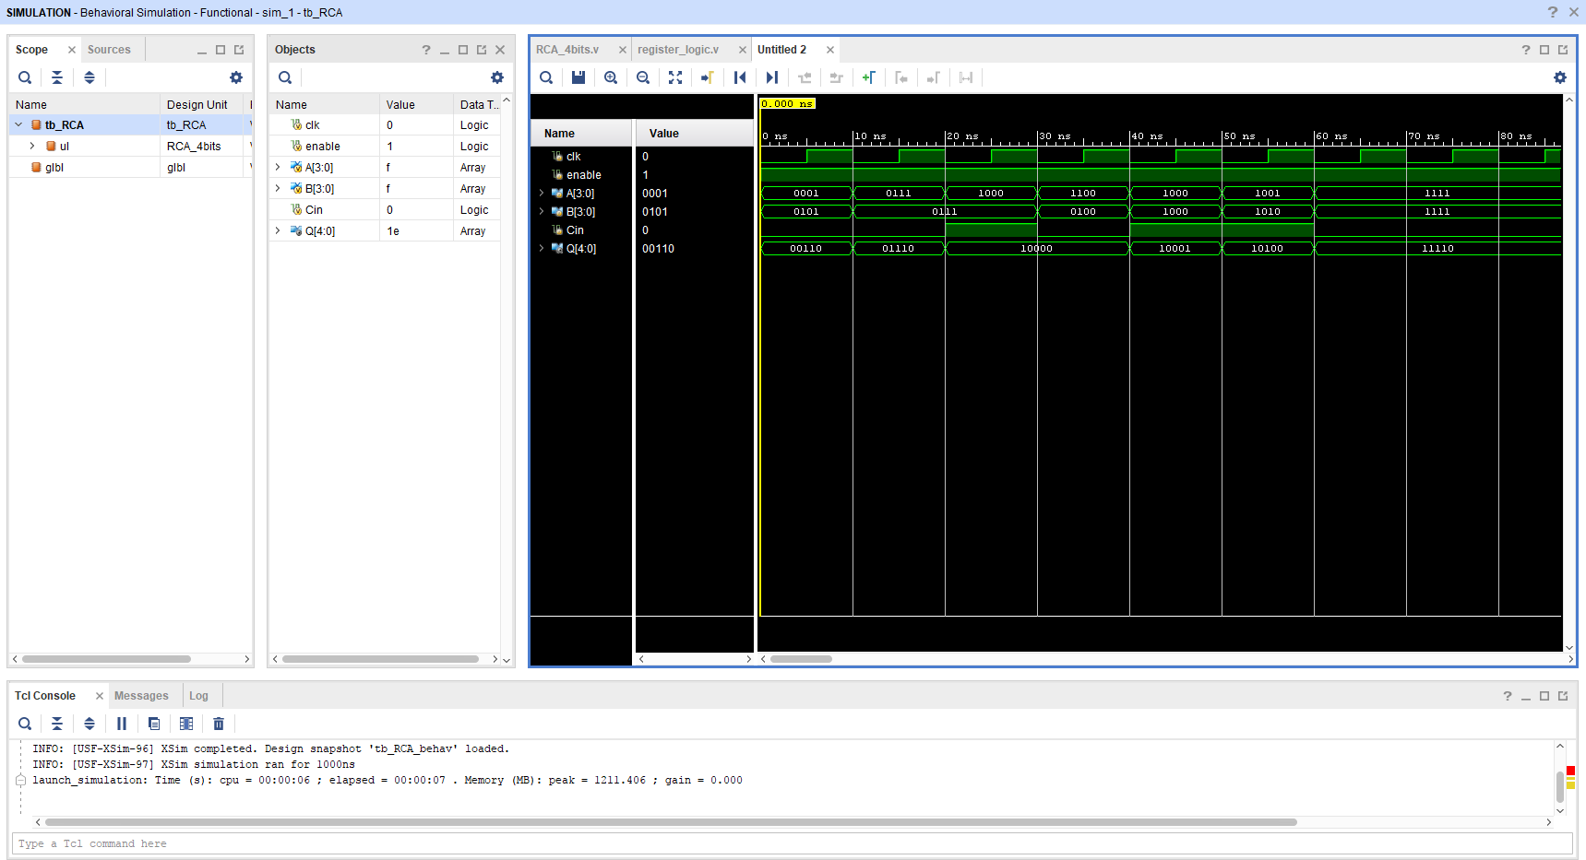

**Part 2 –**

1. All the equations for Ci’sand Si’s

* C[0] = Cin
* C[1] = G[0] + (P[0]C[0])
* C[2] = G[1] + (P[1]G[0]) + (P[1]P[0]C[0])
* C[3] = G[2] + (P[2]G[1]) + (P[2]P[1]G[0]) + (P[2]P[1]P[0]C[0])
* C[4] = G[3] + (P[3]G[2]) + (P[3]P[2]G[1]) + (P[3]P[2]P[1]G[0]) + (P[3]P[2]P[1]P[0]C[0])

1. Design files (.v) for the Carry Lookahead Adder and Register Logic
2. Test-bench
3. Complete Table 2 from the simulation­­­

|  |  |  |  |  |
| --- | --- | --- | --- | --- |
| A[3:0] | B[3:0] | Cin | Sum[3:0] | Cout |
| 0000 | 0101 | 0 | 0101 | 0 |
| 0101 | 0111 | 0 | 1100 | 0 |
| 1000 | 0111 | 1 | 0000 | 1 |
| 1001 | 0100 | 0 | 1101 | 0 |
| 1000 | 1000 | 1 | 0001 | 1 |
| 1101 | 1010 | 1 | 1000 | 1 |
| 1110 | 1111 | 0 | 1101 | 1 |

**Table 2.** Testcases for Carry Lookahead Adder Verification

1. Constraints File (Just the uncommented portion)
2. Simulation waveform for the above test-cases

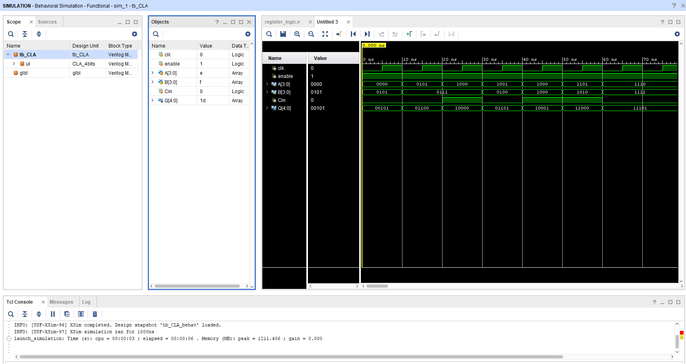

**Part 3 –**

1. Screenshots of the gate-level schematics for both the adder techniques

­­­­­­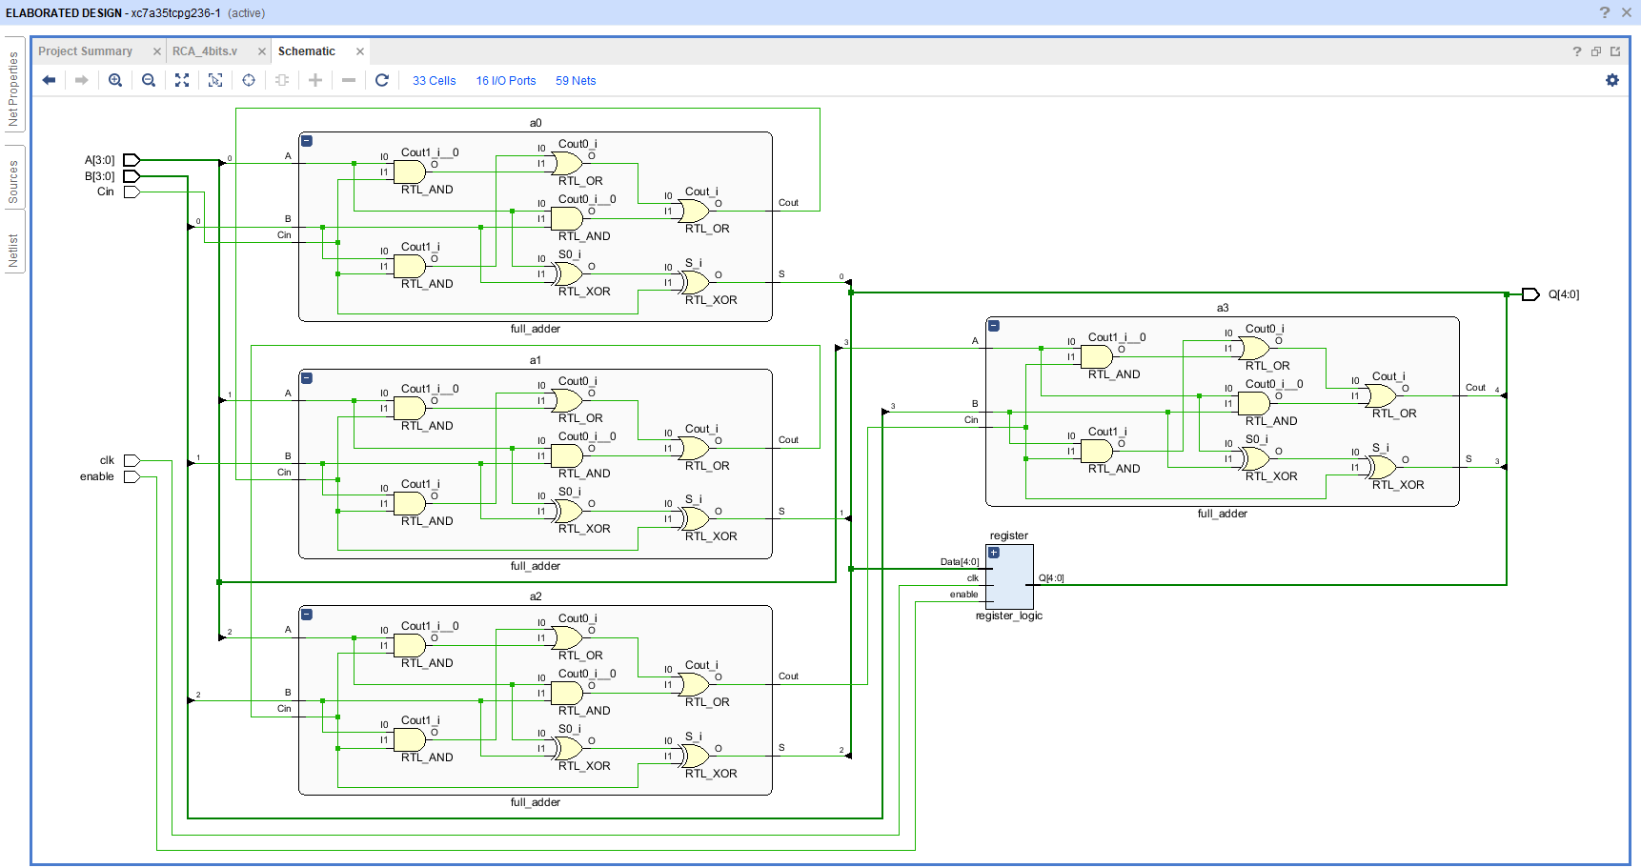

­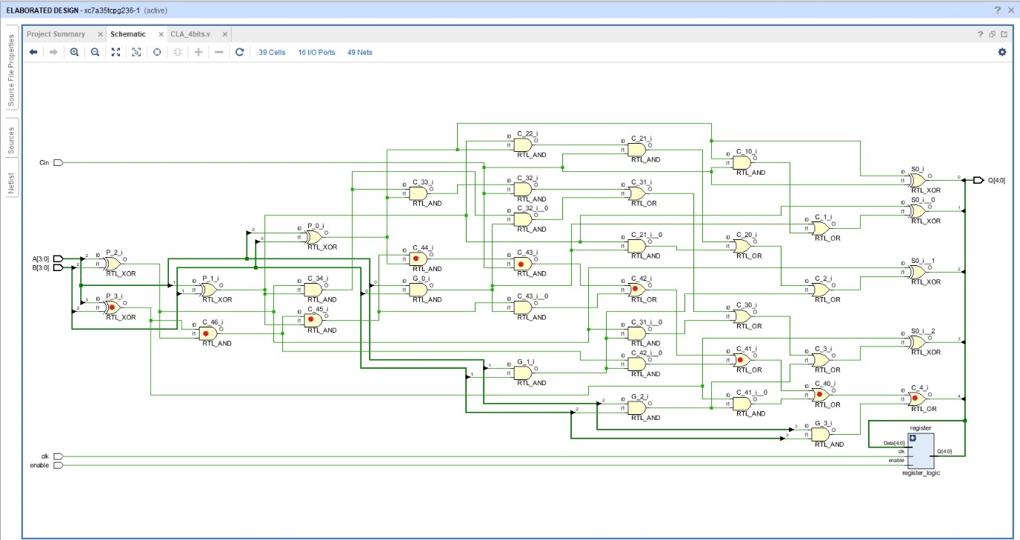­­­­­­­­­

1. Delay and area for both the adder techniques showing all the work

* Ripple Carry Adder
* Delay = 28 ns (By following Cin to Cout) Each full adder has a critical path going from 2nd AND -> 1st OR -> 1st OR (3+2+2 = 7ns)*4 = 28 ns
* Each full adder contains 3 ANDs, 2 ORs, 2 XORs. Using the table and the given areas for each logic gate, we can calculate the area:

3(4) + 2(4) + 2(6) = 12 + 8 + 12 = 32 (for 1 full adder)

4 bit RCA area = 32 * 4 = 128

* Carry Look-ahead Adder
* Delay = 23 ns (By following the red-dotted path) (3+3+3+3+3+2+2+2+2 = 23 ns)
* The above RTL design of the CLA contains 20 ANDs, 10 ORs, 8 XORs.
* 4 bit CLA area = 4(20) + 4(10) + 6(8) = 168

1. Brief conclusion regarding the pros and cons of each of the techniques

* RCA
* Pros
* Small area = less logic gates, which means that production costs will be cheaper
* Cons
* Relatively slow; each Cin is an output from a previous adder (other than the LSB), therefore calculating the sum will take some time in a “ripple” manner
* CLA
* Pros
* More efficient; since each carry signal is calculated in advance based on input signals.
* Cons

1. As we have higher bit CLAs, the logic blocks get more and more complex, thus having to implement more logic gates than the RCA